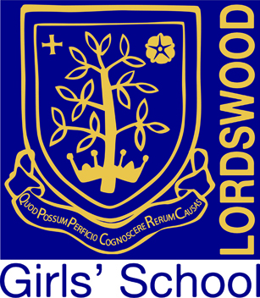

Lordswood Girls’ School & Sixth Form Centre

Knightlow Road, Birmingham B17 8QB

Headteacher: Mrs Jane Götschel

Teacher of Modern Foreign Languages
Spanish and French

Closing Date: Apply by 12 noon on 12th February 2018
Start date: April 2018
Salary: Main Pay Scale
Contract Type: Permanent: will consider 0.8 part-time working (not less than 0.8)

At Lordswood Girls’ School we are constantly striving to improve on our best and we are very proud of our position as one of the top schools, both in the city and nationally. The school has been ranked as one of only five secondary schools in Birmingham in the top 4% nationally based on our recent Progress 8 score, and enjoys an excellent reputation for its academic, sporting, and artistic achievements.

We are looking to appoint an excellent classroom practitioner to teach both Spanish and French, with the ability to teach at least one of the languages to GCSE and ‘A’ level standard. The successful candidate will be passionate about the subject area and able to inspire all students to reach their full potential in this important, popular and successful curriculum area.

In return we offer excellent professional support and a comprehensive development programme.

Application Process:
Application form and further details are available for download from the Lordswood Girls’ School website at www.lordswoodgirls.co.uk and are also available from Sheila Allport by email at s.allport@lordswoodtrust.co.uk or telephone 0121 429 2838.
Application deadline is 12.00 noon on 12th February 2018

Lordswood Academies Trust is committed to safeguarding and promoting the welfare of children and young people and expects all staff to share this commitment. An enhanced DBS check is required for the successful applicant.

