13th October 2017
PARENT GOVERNOR ELECTION
Dear Parents,
The governing body is responsible for both the conduct of the school and for promoting high standards. In conjunction with the Trust, the governing body carries out its role by setting the vision for the school and then ensuring that the school works efficiently and effectively towards achieving its vision. It does this by building a thorough knowledge of the school and its community, by both supporting and constructively challenging the school, and by ensuring accountability and compliance. The governing body of our school is made up of elected parent governors and co-opted governors.

A vacancy has arisen for a parent governor on our governing body, and the governing body is asking for nominations of interest of someone with parental responsibility for a child at the school.
Before you decide to nominate someone, or indeed stand yourself, you may want to know a bit more about what is involved. Governors need not be experts in the field of education. What they do need is an interest in the school and in the welfare of our children and the time and willingness to get involved. The skills you have can be very useful to the local governing body.
In terms of ‘soft skills’, the ability to be able to build relationships with a range of people, to be able to work as part of a team, to be able to question, and to make connections between different types of information is important. All governors are expected to be able to read data on school standards.

Our governing body expects governors to:
- attend two meetings of the full governing body per term – these are normally on Wednesdays at 5.00pm
- be available for additional ad hoc meetings if required
- potentially sit on one of the Trust’s governing sub-committees and attend their meetings which are usually a maximum of two a term.
- link with a member of the senior leadership team on a key area of the school’s work, aim to visit the school once a term and report back to the governing body on a regular basis
- commit to attend training courses, which may be internal or external

In return, our governing body will provide you with induction and support during the initial months as well as access to required/suitable training.

The enclosed sheet summarises who may not serve as a governor. Nominations must be from parents or carers with children at the school on the day that nominations close.

If you would like to stand for election please complete the enclosed nomination form and return it to the school not later than noon on Friday 20th October 2017. You may also include a short personal statement to support your nomination, which should be no longer than 200 words. Self-nominations will be accepted. If you are nominating another parent, please seek their prior consent. Please send the form to the school via the post, your child, or bring it into Reception, marked “Parent governor election”.

If there are more nominations than vacancies the election will be by secret ballot. If that is necessary, voting papers will be sent to all parents together with details of the ballot procedure.

If you have any further questions on being a governor, please email our Clerk and we will get back to you.
I look forward to hearing from you
Yours faithfully,
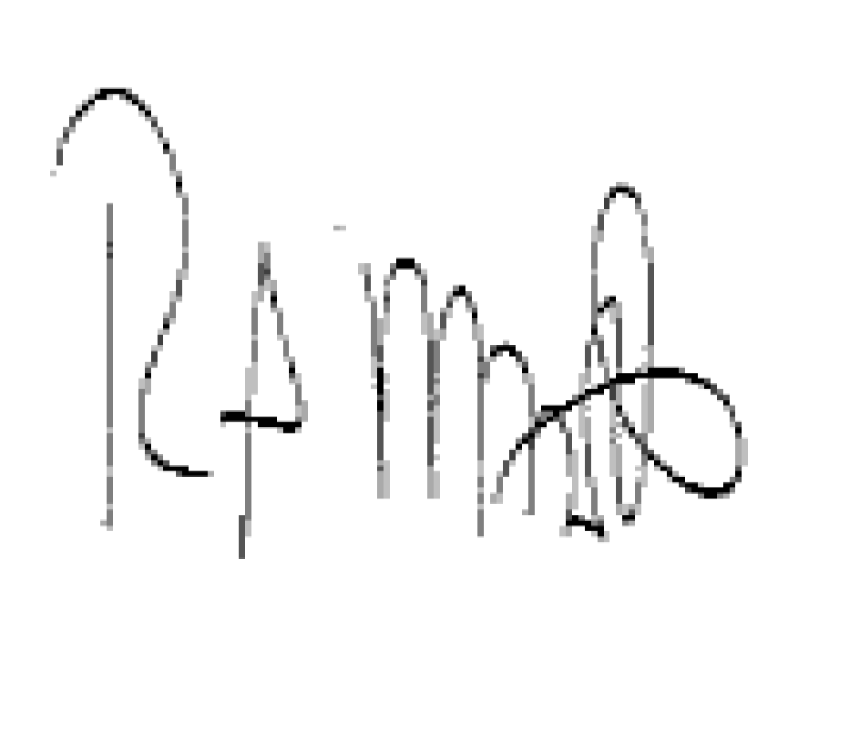
Ralph Minott
Chair of Governors

Clerk: Tracy Rolf (returning officer)
0121 429 2838
t.rolf@lordswoodtrust.co.uk

