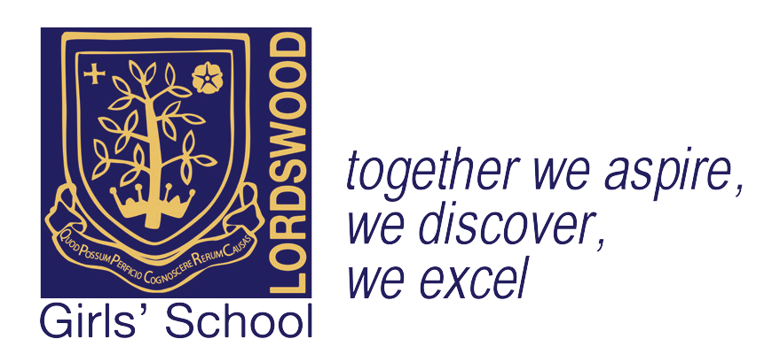
Headteacher: Mrs. J. Götschel B.A, MEd.

Lordswood Girls’ School
Lordswood Girls’ School
Knightlow Road Birmingham B17 8QB

Tel: 0121 429 2838
Facsimile: 0121 429 4840 Email: lgs-enquiry@lordswoodtrust.co.uk

11th January 2018

Dear Parent/Carer,
GCSE Computer Science Resources

In order to support students in their preparation for GCSE computer science, I would like to offer them the opportunity to purchase the resource listed below.
CGP GCSE OCR Computer Science - Complete Revision & Practice which delivers hassle-free revision notes and examination style practice questions with answers for all areas of the specification. The book also has a full mock examination and mark scheme for both components. This resource has a RRP of £10.99, however we are able to offer students the opportunity to purchase the book for the price of £5.50.
Payment can be made by cash or cheque; please complete and return the reply slip below with the relevant monies. The Finance Team will be collecting payments in the GCSE computer science lesson on Tuesday 16th January and Tuesday 23rd January. Cheques should be made payable to ‘Lordswood Academies Trust’. Please do not send payments into school on any other times than those mentioned above. .

Yours sincerely,

Mrs L Venn
Lead Professional in ICT and Computing
………………………………………………………………………………………………………………………………
GCSE Computer Science Resources
Student: …………………………………………. Review group: …………….
I would like to purchase the GCSE Revision Guide.
Please tick:
- I enclose a payment of £5.50 for the Revision Guide

Signed …………………………………………………………… Date ………………………………….

Lordswood Academies Trust Registered Number 7567230 Registered Office: Knightlow Road, Harborne, Birmingham, B17 8QB

