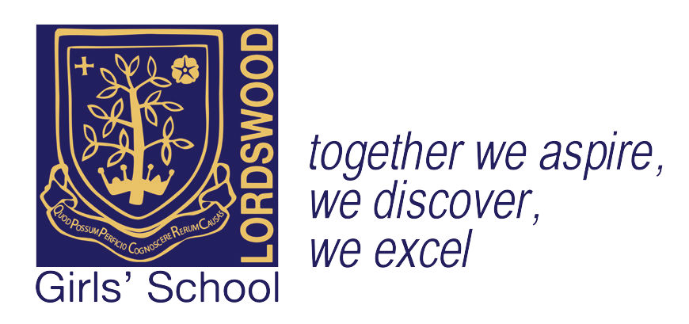
Headteacher: Mrs. J. Götschel B.A, MEd.

Lordswood Girls’ School
Lordswood Girls’ School
Knightlow Road Birmingham B17 8QB

Tel: 0121 429 2838
Facsimile: 0121 429 4840 Email: lgs-enquiry@lordswoodtrust.co.uk

19th September 2017

Dear Parent/Carer,
Key Stage 4 Spanish Resources

In line with the GCSE Spanish aims and learning outcomes, students will be assessed on their ability to communicate effectively in Spanish for different purposes and audiences. They must use their knowledge of vocabulary and grammatical concepts to produce extended responses of varying lengths and types to express ideas and opinions in Spanish. Translation from English to Spanish and from Spanish to English is also a key skill that will be assessed. In order to support students in their learning, we would like to offer them the opportunity to purchase the resources listed below.
Edexcel Revision Guide and Edexcel Revision Workbook delivers hassle-free question practice for reading and listening, with a dedicated grammar section. The books cover the themes, topics and grammar studied in class and with target grades on the page, the resources allow students to progress at the right speed, while Exam Alerts highlight common pitfalls and misconceptions in exam questions. These two resources RRP at £5.99 each, however we are able to offer students the opportunity to purchase both books for the combined price of £5.00.
¡Viva! Grammar and Translation Workbook is a dedicated workbook that supports and consolidates grammar learning and translation skills. Spanning Higher and Foundation tiers, it contains explanations of key grammar points, verb tables, and translation exercises (both into Spanish and into English) aimed to embed grammatical knowledge. Students are encouraged to use the language independently through a bank of revision translations bringing together grammar and vocabulary learning from throughout the course. The workbook can support self-study and links directly to the textbooks that students use in the classroom; the cost of this resource is £5.99.
In line with the themes and topics studied at GCSE, in order for your daughter to develop her range of vocabulary and complete activities to the best of her ability in class and at home, it is vital that your daughter has a bilingual dictionary and brings it to every lesson. The Modern Foreign Languages Department is able to offer students the opportunity to purchase a dictionary suitable for GCSE study at the discount price of £5.00.
Payment can be made cash or cheque, please complete and return the reply slip below with the relevant monies. The Finance Team will be collecting payments in the ante-hall at 8.15 am on Tuesday 3rd October, Tuesday 10th October and Thursday 12th October 2017. Cheques should be made payable to ‘Lordswood Academies Trust’. Please do not send payments into school on any other times than those mentioned above. .

Yours sincerely,

Miss L. Siviter
Lead Professional in Modern Foreign Languages
………………………………………………………………………………………………………………………………
Key Stage 4 Spanish Resources
Student: …………………………………………. Review group: …………….
I would like to purchase the GCSE Revision Guide with Workbook / Grammar and Translation Workbook / Spanish Bilingual Dictionary (please delete as applicable)
Please tick:
- I enclose a payment of £5.00 for the Revision Guide and Workbook
- I enclose a payment of £5.99 for the Grammar and Translation Workbook
- I enclose a payment of £5.00 for the Spanish Bilingual Dictionary

Signed …………………………………………………………… Date ………………………………….

Lordswood Academies Trust Registered Number 7567230 Registered Office: Knightlow Road, Harborne, Birmingham, B17 8QB

